**Power BI Connection With Microsoft Fabric**

**Power BI : Power BI** is a business analytics and data visualization tool developed by **Microsoft** that enables users to connect to various data sources, transform and model the data, and create **interactive reports and dashboards**.

**Microsoft Fabrics :** **Microsoft Fabric** is an **end-to-end data analytics platform** from Microsoft that unifies data engineering, data integration, data science, real-time analytics, and business intelligence all in **a single, integrated environment**.

Before exploring Microsoft Fabric, it's important to first understand the concepts of One Lake and **Data Lake**, as they form the foundation of the platform.

**Data Lake:**

A Data Lake is a centralized repository that allows for the storage and processing of large volumes of structured, semi-structured, and unstructured data from various sources.

**One Lake :**

**OneLake** is a **unified, logical data lake** designed to serve the entire organization. It acts as the **foundation for all workloads in Microsoft Fabric**, providing a centralized and consistent storage layer. In Microsoft Fabric, this integrated data lake is referred to as **OneLake**, enabling seamless data access and collaboration across different services and teams.

In Microsoft Fabric, **OneLake** is integrated directly into the platform. Within OneLake, we can view and manage files created in **Lakehouses**, **Warehouses**, and especially **Semantic Models**. These **Semantic Models** are what we connect to **Power BI** for building interactive reports and dashboards.

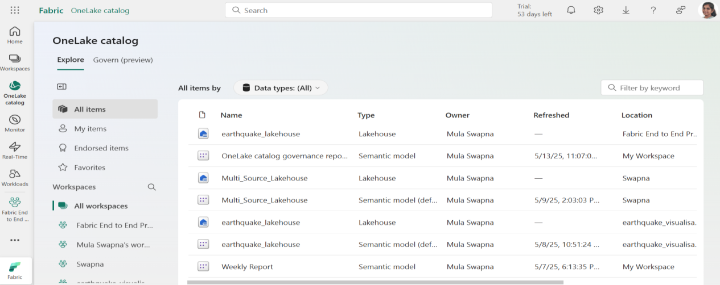

Whatever we‘ll see the semantic models in One lake we can access it into Power BI. The files automatically upload into One Lake when the Lakehouse and Warehouse runned successfully. Even we can use the published power bi semantic models too.

In Power BI, we can connect to Microsoft Fabric through various components, enabling seamless access to data across the platform. These components include:

* Power BI Semantic Models

* Data Flows

* Datamarts(Preview)

* Warehouse

* Lakehouse

* KQL Databases

* SQL Database

Here is a **comparison table** for the options listed under the **OneLake catalog** in **Microsoft Fabric**, focusing on their **usage and connection with Power BI**:

|  |  |  |  |  |  |
| --- | --- | --- | --- | --- | --- |
| **Component** | **Purpose in Microsoft Fabric** | **Data Type Support** | **Query Language** | **Power BI Connection** | **Best Use Case** |
| **Power BI Semantic Models** | Reusable datasets for reports and dashboards | Structured (Tabular) | DAX | Directly used to build reports; connect via Power BI Desktop | Central model for report development; enables reusability and governed data |
| **Metric Sets** | Predefined KPIs and business metrics | Aggregated numeric | N/A | Visualize in Scorecards (Power BI goals) | Tracking organizational performance using goals and KPIs |
| **Datamarts (Preview)** | Self-service analytics combining data prep, modeling, and storage | Structured | T - SQL, DAX | Power BI auto-connects; semantic model auto-generated | Lightweight data warehouses for analysts with minimal engineering knowledge |
| **Lakehouses** | Combines Data Lake & Data Warehouse with Delta tables | Structured & Semi-structured | PySpark, SQL | Power BI connects to Delta tables and auto-generated models | Big data processing, data science, and machine learning-ready analytics |
| **Warehouses** | Enterprise-grade SQL-based analytics storage (OLAP) | Structured | T - SQL | Semantic model created automatically; connect from Power BI | High-performance analytical workloads with structured schema (star/snowflake) |
| **KQL Databases** | Real-time analytics using telemetry, logs, and time-series data | Semi-structured (JSON, logs) | KQL - (Kusto Query Language) | Connect via DirectQuery in Power BI (for supported scenarios) | Real-time monitoring, IoT, telemetry data analysis |
| **SQL Databases** | Relational SQL database supporting structured data with transactional features | Structured | T - SQL | Semantic model created; connect directly from Power BI | For traditional relational workloads with Power BI reporting integration |

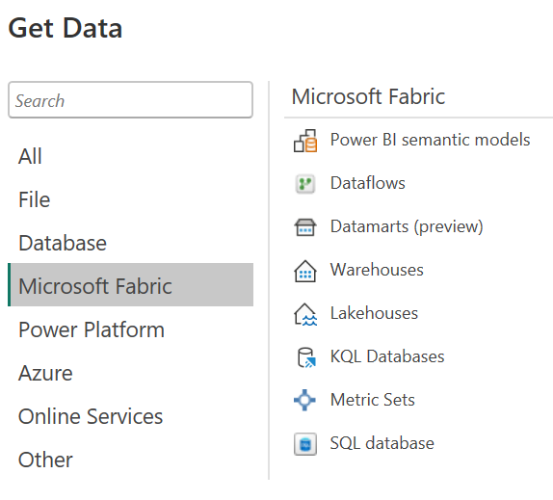

**Power BI semantic models** :

**Semantic Models** in Microsoft Fabric are essentially **datasets** that define the structure and logic of the data used for reporting and analysis. When reports are published, or when **Lakehouse tables** and **Warehouse tables** are created, **Fabric automatically converts them into Semantic Models**. These models can then be **directly connected to Power BI** for building interactive reports and dashboards.



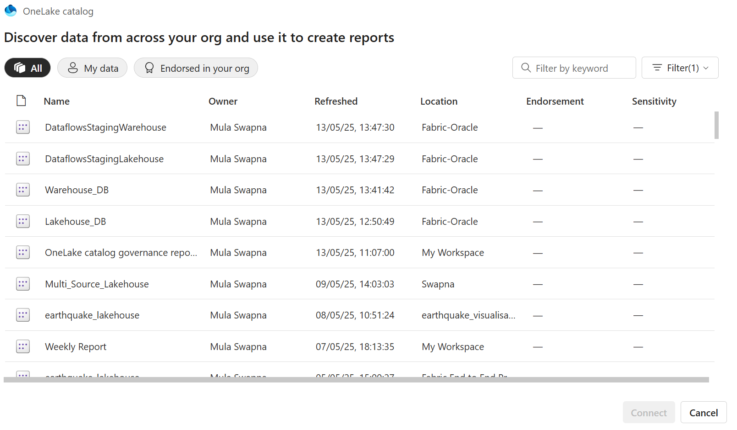

We can select the required **dataset** from the available **Semantic Models** in Microsoft Fabric to use in Power BI for analysis and reporting.

**Lakehouse :**

Microsoft Fabric Lakehouse is a data architecture platform for storing, managing, and analyzing structured and unstructured data in a single location. It's a flexible and scalable solution that allows organizations to handle large volumes of data using various tools and frameworks to process and analyze that data.



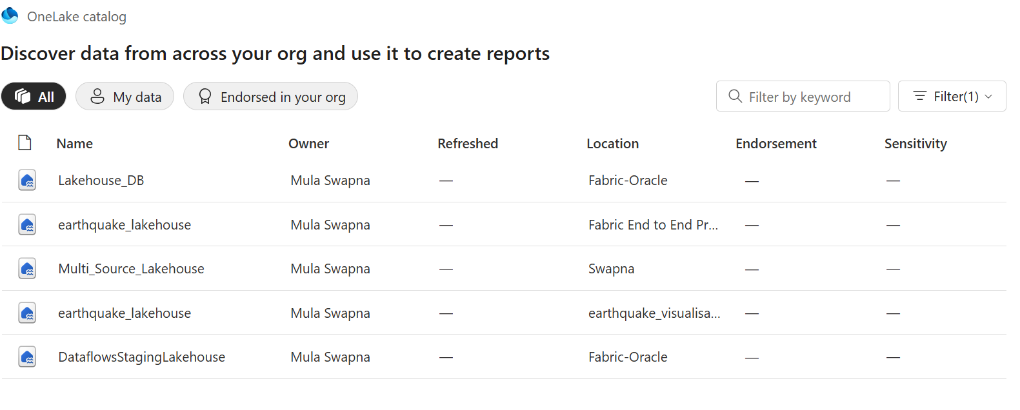

**Warehouse :**

**Warehouse** in Microsoft Fabric is a platform used for **storing and analyzing structured data**. It is designed for large-scale data storage and supports querying using **T-SQL (Transact-SQL)**, the same language used in traditional SQL databases, making it familiar and efficient for data professionals.



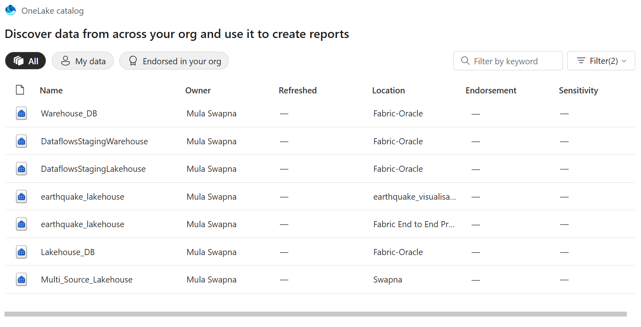

**KQL Databases :**

**KQL (Kusto Query Language) Database** in Microsoft Fabric is designed for **real-time intelligence and analytics**. While it doesn’t support direct connections to Oracle, you can import data from Oracle into the KQL database through **pipelines** or **dataflows**. Once the data is in KQL, you can apply changes using **KQL queries** and then connect it to Power BI for reporting and analysis.



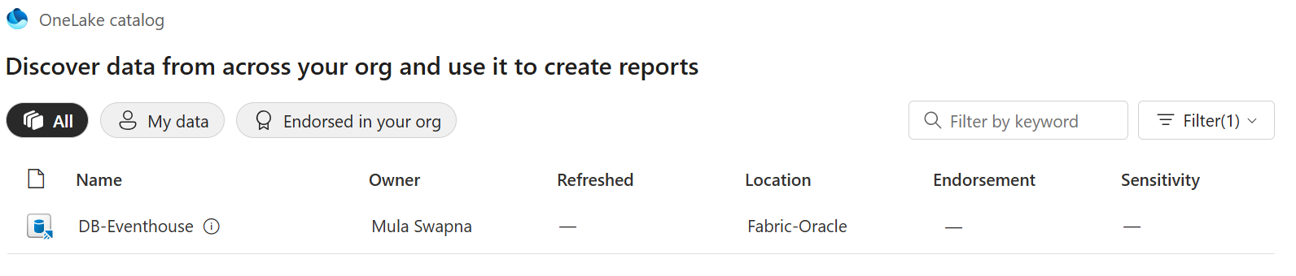

**SQL Databases :**

In **Microsoft Fabric**, a **SQL Database** is a **relational database environment** built on top of the **Fabric platform**, designed for **structured data storage, querying, and analysis** using **Transact-SQL (T-SQL)**.



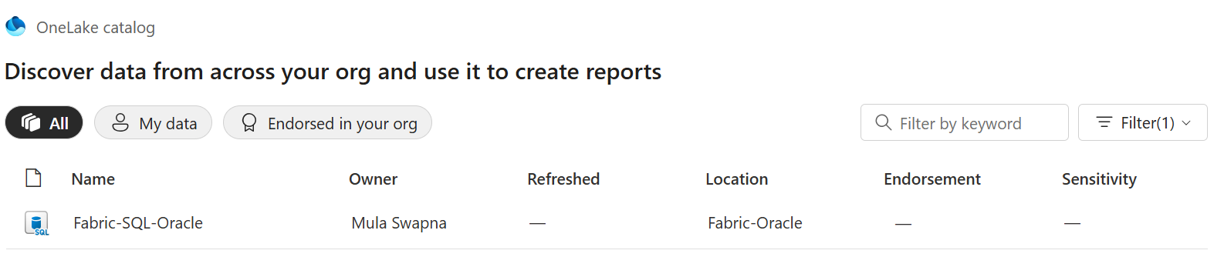

**Datamarts :**

A **Datamart** in Microsoft Fabric is a self-service analytics solution that combines data ingestion, transformation, and storage with an auto-generated semantic model. It uses a built-in SQL database and Power Query for shaping data. Power BI connects directly to the semantic model for report building.



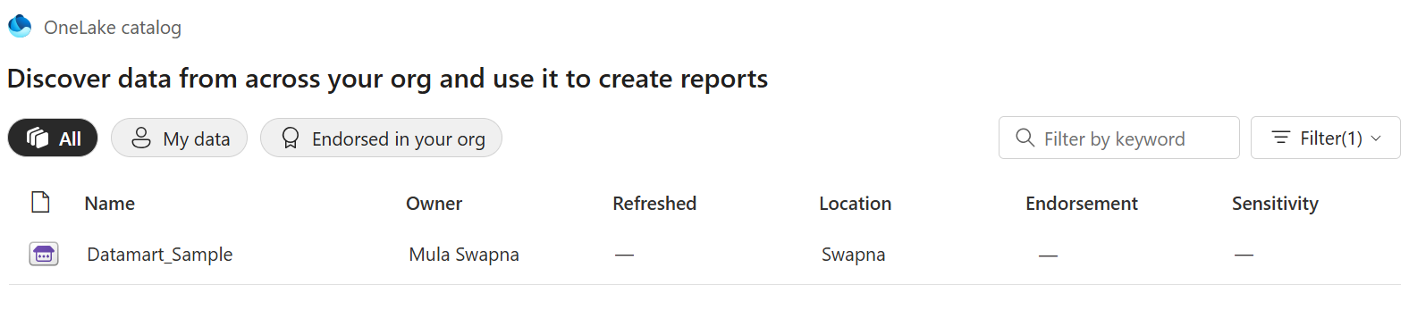

**Dataflows :**

**Dataflows in Microsoft Fabric** are cloud-based ETL processes that use Power Query to connect, transform, and load data from various sources into Lakehouses, Warehouses, or Datamarts. They enable centralized, reusable data transformation logic that can be directly connected to Power BI for reporting.

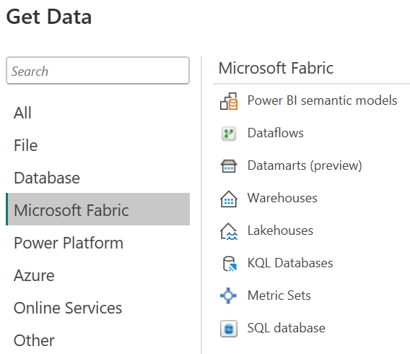

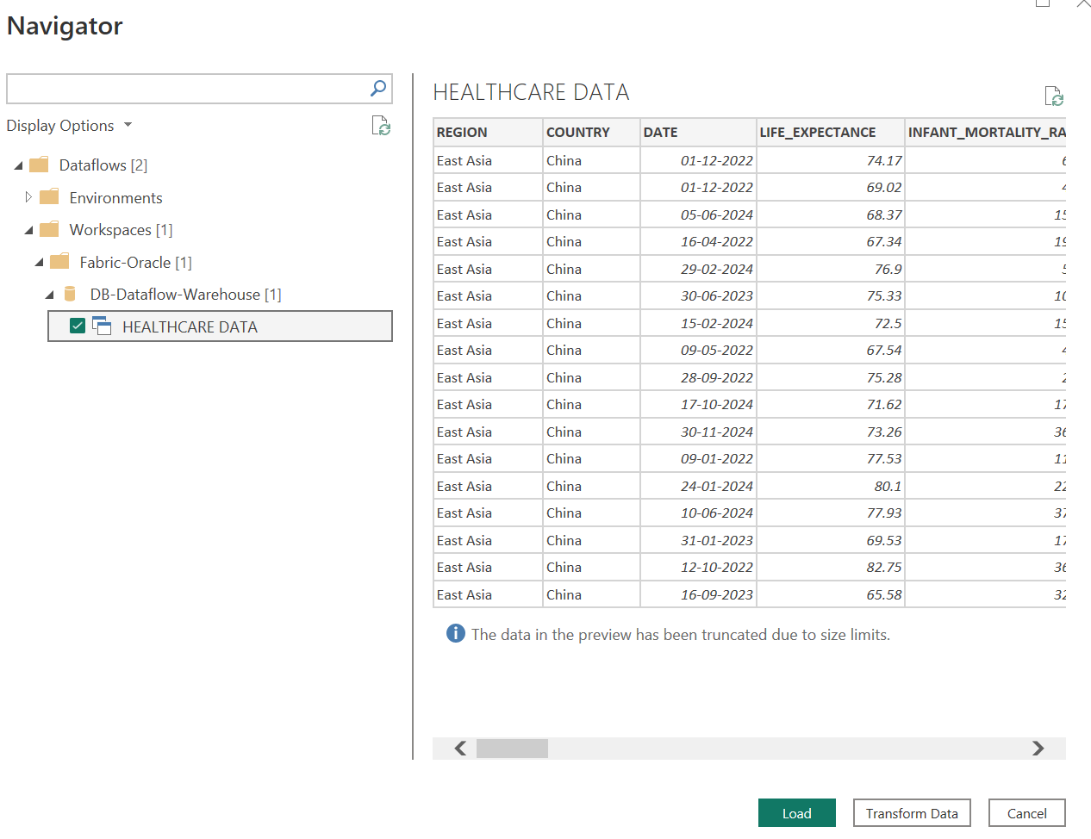

**Metric Sets :**

**Metric Sets** in Microsoft Fabric are reusable collections of KPIs and metrics built on top of semantic models (like Lakehouse or Warehouse tables). They allow you to define standardized measures (e.g., Revenue, Profit Margin, Growth Rate) that can be easily used across reports and dashboards in Power BI, ensuring consistency and quick access to key performance data.



In Power BI, metrics can be created in two ways:

1. Through **Microsoft Fabric** by using the **Metric sets** option.
2. By adding a **Metric visual** directly from the **Visualizations pane** within a Power BI   
    report.